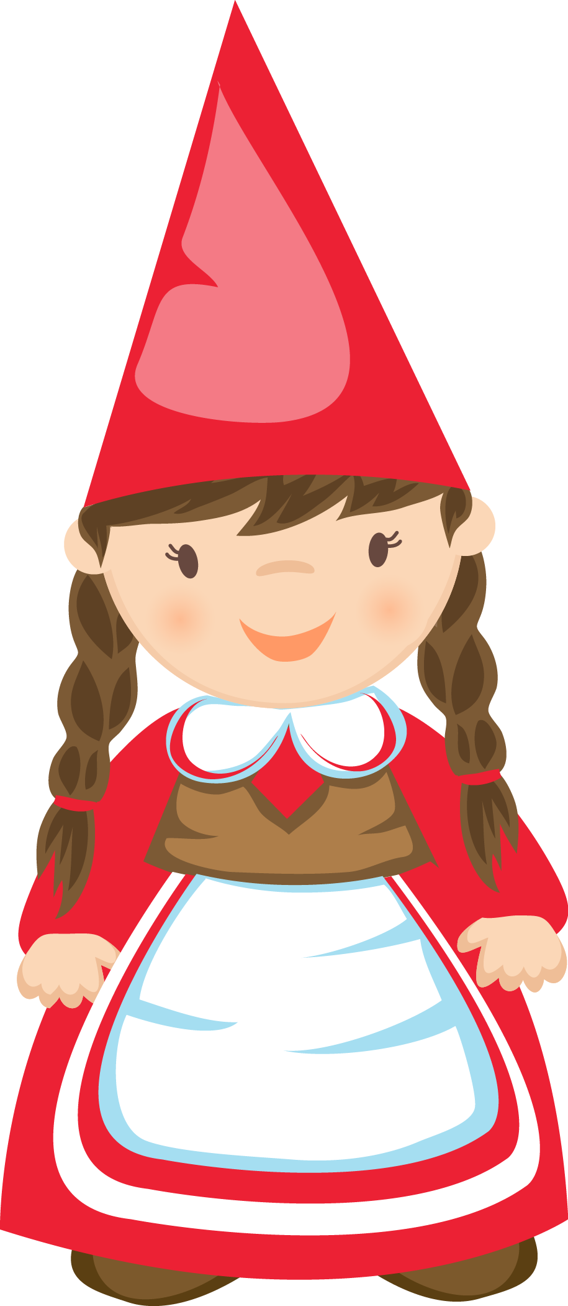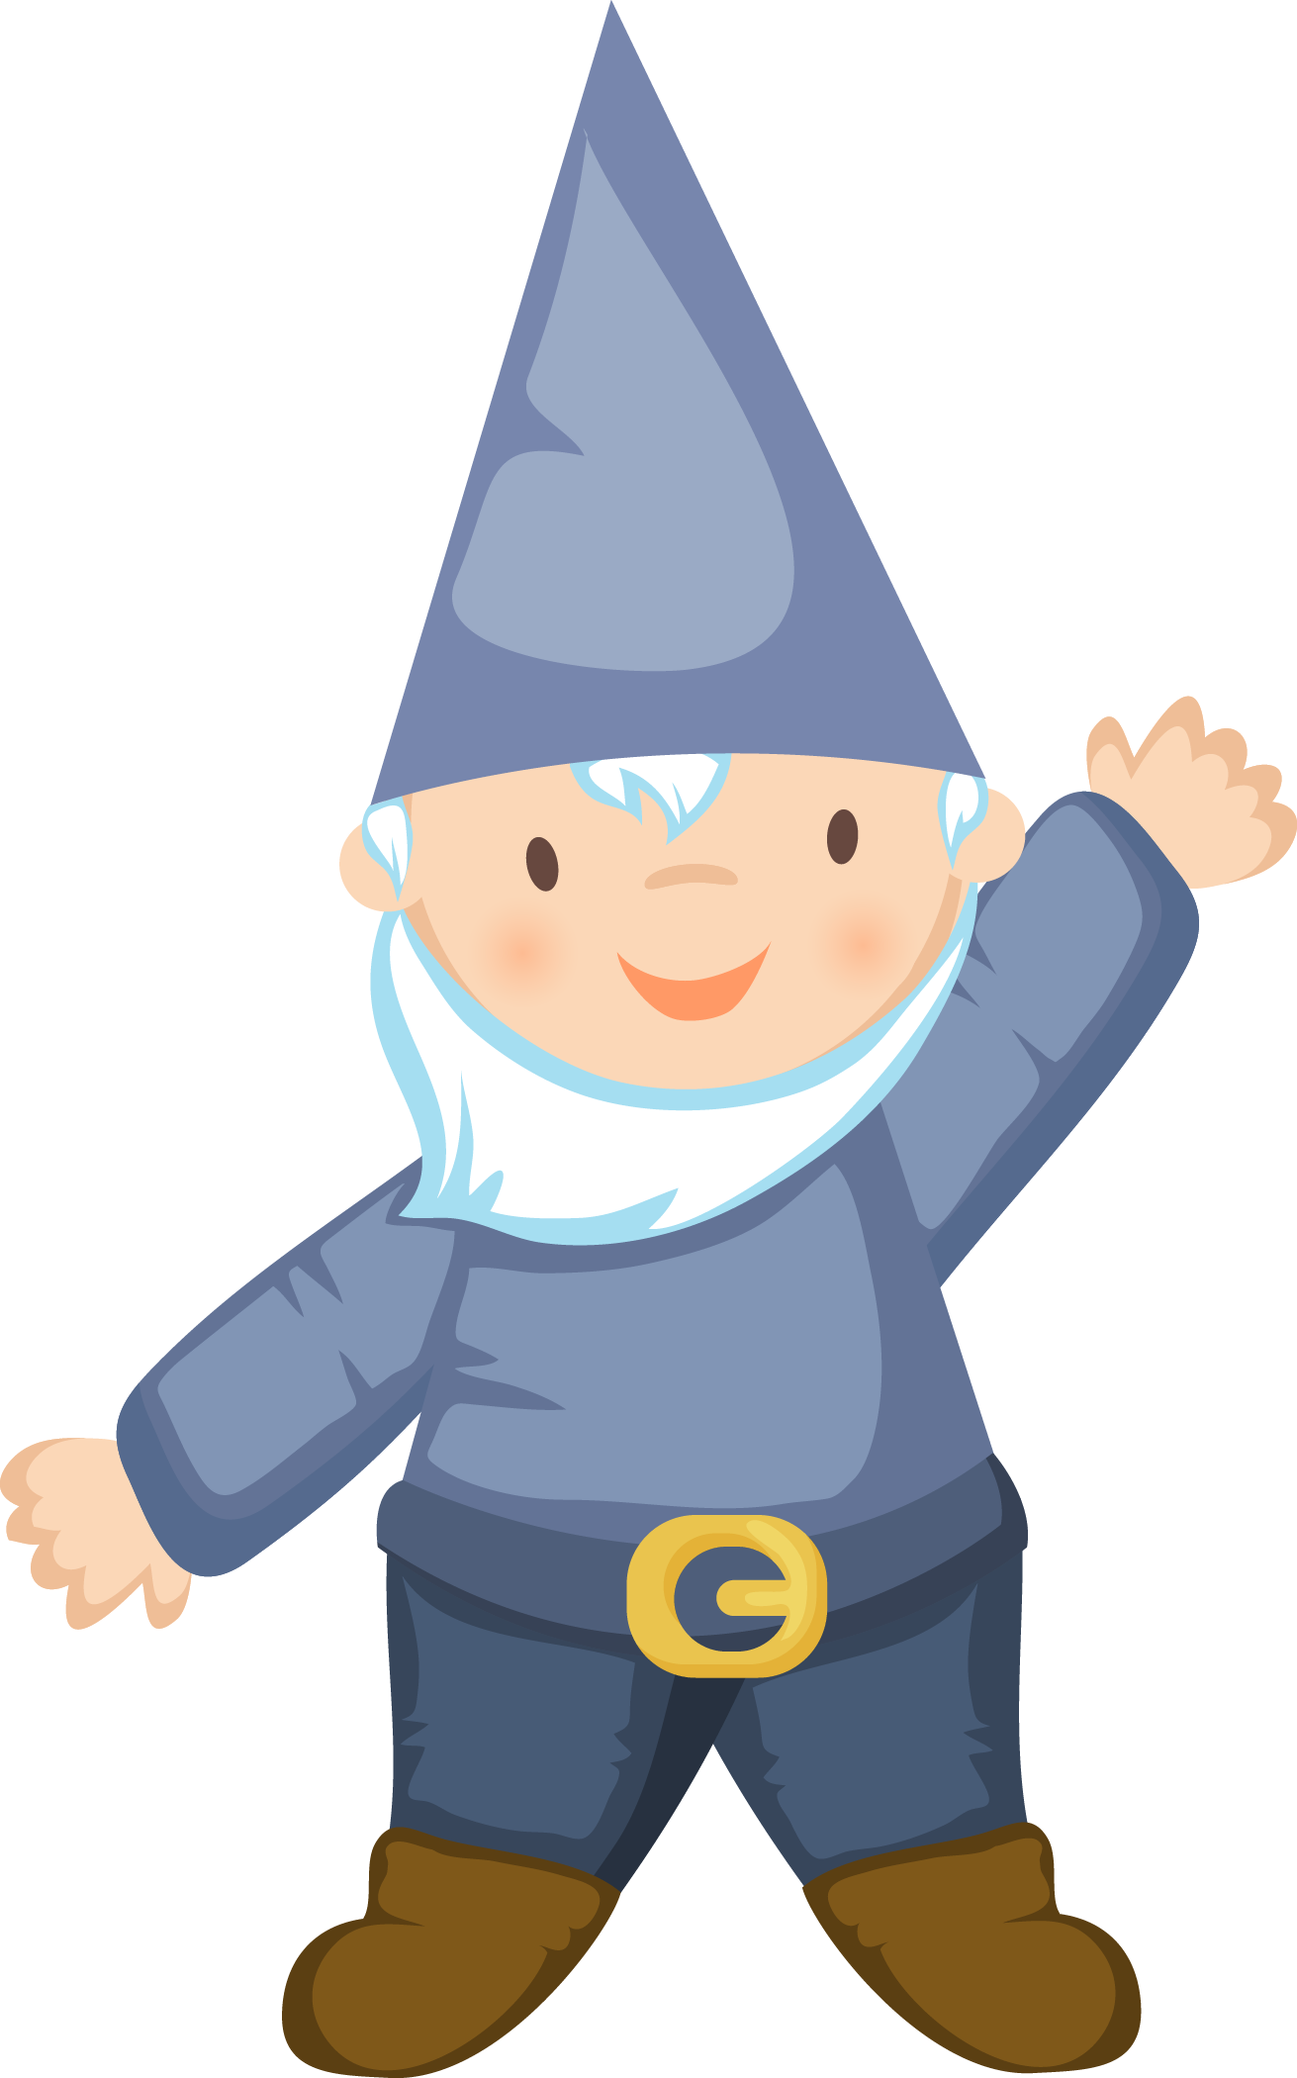

GRAPHICS by JW Illustrations © JESSICAWEIBLE.COM

Hilda and Mats
And the Lost Sack of Presents
Ann Keeler Evans^{©2015}

“Hurry up!” Hilda urged her best friend Mats. “The Moon’s just about in the right place.

“Oh! Coming!” he responded rushing to grab his scarf, coat and favorite blue hat.

They went outside and joined the parade of folk walking toward the meadow above the river.

Normally, this time of year, the gnomes would have been so bundled up that it would have been difficult to tell one red capped soul from another. But it was so warm this year they were taking their picnics along to eat by moonlight. It was more than 15˚ — 60˚ to the American Humans — unheard of weather for right before Christmas. And what luck this year! The Full Moon fell on Christmas Day, which meant the reindeer would have clear skies for delivering their wares.

Now what most humans don’t know is that presents are moved in stages and stored in secret present depots. Most gnomes don’t know this either. This village had learned about the depots because Wee Will (who, though called Wee, was still at least six inches taller than any gnome in the village) had fallen in love with a sweet gnome named Gretel and had come to live in her community along this great river.

Before he married Gretel, however, Wee Will had worked at the Pole in Shipping and Distribution. He was the one who told the gnomes that, during the week before Christmas Eve, the reindeer ferry sled-loads of toys and presents to magical depots all over the world. We all love the notion that Santa flies one straight line around the world. But as the population increases, so does the demand for presents. Even magic can only stretch so far — there are rules for Magic, too, you know. So the idea of present depositories had begun to make a lot of sense to the elves. Lists were finished, presents were packed, village by village, and sent off to the depots and no one was the wiser. These days, the Jolly Man in Red has help from his children and nieces and nephews and, of course, the elves and reindeer to get the job done right.

Cherishing this secret, the gnomes had established a treasured tradition. They were pretty certain that they lived quite close to a depot — although they hadn’t the slightest idea where it was. Magic is magic because it has its secrets. However, or perhaps, therefore, since Wee Will’s arrival, every year, all the inhabitants of the gnome village would traipse out into the meadow above the river on the nights before Christmas to see the sleds ferried to their secret destinations. Because they were magic creatures, just like the elves, the gnomes were able to see the sleds fly by — if they knew to look for them… and on Christmas Eve, they sometimes saw Father Christmas himself. Once, it was said, he’d even waved.

This fine evening as the fog drifted, covering and uncovering the Moon, the gnomes sat on their woven willow pads, ate nutcakes, drank hickory bark ale, and gossiped. What better way to celebrate the season of giving than to watch it from the very beginning. Oh, the gnomes found this just the right way to begin their holiday celebrations.

“There!” someone shouted… and sure enough there was a tiny speck coming into view. The gnomes stood and hooted and hollered! Whoever was driving obviously knew they were there because he made a flashy circle before speeding off.

Everyone stood waving and then gasped. For a sack of presents was falling off the back of the sled! Everyone dashed across the meadow (gnomes can move very fast for short periods of time when they need to), They came together into a large group and lifted up their arms to catch the sack before it hit the ground and something was broken. “Got it!” they exhaled.

As they lowered it to the ground, they looked at each other. “Whatever shall we do,” they wondered. And they stood in a clump and thought.

Wee Will! He would know! He had worked for Santa. He would know what to do! He would know how to get the reindeer to fly by and pick up the package! He could fix this! In unison, every head turned toward Will…

“Ahem,” Wee Will cleared his throat. “This is not good…”

“I can’t fix this,” he said. “There’s no way to get in touch with the driver. If they had gps, then they could be tracked by humans, which isn’t good. The Elf-only technology is still in testing. Only Santa can be tracked by NORAD, and that only happens when he lets it happen. What makes this all so magical is that when everything is ready, Santa says “Now!” and then it all rolls along. Except when you have young show offs like this one, who doesn’t pay attention…

“I’m afraid there are just going to be some young humans who aren’t going to get their packages.”

Hilda was at the edge of the group. She could see a dolly spilling out of the bag carrying a tag that read

To: Alea
From: Santa
Merry Christmas!

“It’s so sad,” she said to Mats, “Alea’s never going to get her dolly. And the elves made it especially for her!”

“That’s so sad,” said Wee Will, “where does Alea live, maybe we can get it to her somehow… Can we mail it?”

“I don’t know,” says Hilda, “it just says Alea.”

“Squint!” said Wee Will, “It’s written right there, for elves and gnomes to see. There you are: Winfield.”

“Oooh, that’s just the next town,” said Hilda.

“Might as well be the Moon,” says Mats, “It’s Christmas Adam, the day before Christmas Eve. How are we going to get it there?”

“Papa,” said Hilda, “what about the wagons. Couldn’t we take the wagons?”

Papa was smiling and nodding proudly. “Good thinking, girlie! Everyone’s got wagons.”

“We could load them up and pull them to the next town. And then we could deliver them. We could be the Christmas Elves this year!” said Hilda.

“Hilda,” said Wee Will, “that’s a wonderful idea… But gnomes can only move quickly for a very short time. That’s a long way to walk. It’s probably five miles. And this sack contains gifts for a whole village. That’s a lot to carry.”

“But we can’t do nothing, Wee Will. Alea needs her new dolly. Alea would be sad. Dolly would be too. No one will love her like Alea.”

“Hilda’s right, those kids need their presents.” said Mats. “There has to be a way to get those presents there faster than our walking. I don’t mind trudging, but I want them to have their presents when they wake up. No one should be disappointed on Christmas. Why there are already silly children who don’t believe. It could be a disaster! An entire town could stop believing in Santa. That would be terrible.”

The whole village gasped. That would be terrible. That was not acceptable. So everyone thought again.

“What if,” said Gertie, the oldest gnome of the clan, “what if, we asked the animals to help us? Do you think that would work, Steffan?”

“Well,” said Steffan, uncomfortable to be in the spotlight, “let me ask.” Steffan cocked his head to the side and closed his eyes. After a bit he righted his head and smiled, “They might do, let’s see.”

And right after that Lucy, the Yarbetter’s golden retriever, came dancing into the meadow, accompanied by Miss Puss, Sally Smith’s cat. “Lucy, stop pouncing about, it’s annoying,” hissed Miss Puss. Lucy grinned and washed Miss Puss’ ear.

“Steffan let us know what’s going on,” said Miss Puss. “Here’s what I think we can do. We’ve put out a call to all the feral dogs and cats who would like their pups and kits to have a lovely life in a good home, and the grown up animals will pull the wagons — if the gnomes will make bows and beds for the littles and they can be delivered along with the presents.

“But how will we know if the families want a pet?” asked Hilda. “It wouldn’t be fair for the pups and kittens to fall in love with a family who don’t want them.”

Wee Willie spoke up… “oh, the animals will know which present they belong with. The animals can tell by the tags. Pets are magical too, you know. Oh, this is wonderful. This will save Winfield’s Christmas. Let’s get everything organized and packed. I didn’t work at the North Pole without learning how to manage one little bag. Big deal for Winfield, not much for us now we have a plan!”

So everyone fetched their wagons and long discussions ensued over who would go. Pretty soon, in addition to the gnomes and the wagons, there were lots of dogs and cats and their pups and kits swirling around the meadow. It was chaos. But gnomes are excellent organizers. No chaos can stand up to a village of gnomes and expect to get anywhere!

The gnomes got busy packing wagons, making sure there was room for the puppies and kitties who were settling down alongside the presents they had decided they belonged too. They counted presents. They counted noses. They tucked blankets and bows into the corners so everything was protected. They needed a few more pets and weren’t sure what to do. But, fairly soon, another three dogs and two cats who had been undecided brought over their babies. It was hard to let them go but they knew that inside dogs and cats live much better lives. The adults were suspiciously bright eyed, but determined. Who doesn’t want a better life for their children?

Lucy sat grinning by Miss Puss. “This is hilarious. If anyone ever heard that cats were going to pull wagons, they would never believe it,” she said.

“Oh,” sniffed Miss Puss, “as if the humans would really believe in packages that could fall off Santa sleighs and in gnomes who would circle the wagons to make sure that human children received their Christmas presents! Although, if they believed anything, everyone could believe a golden retriever would participate, Luce! You silly, eager things.”

“Humans,” laughed Lucy. “They’re dear, but they sure don’t know a lot about magic. What a riot. This is the year that Winfield will get new pets. Everyone will be friendly because they’ve all pulled together to make this happen. Winfield won’t know what happened. And look at our little Hilda, she and Mats are really growing up well, aren’t they?”

“Purrrrrrr,” rumbled Puss, contentedly.

Since it had been Hilda’s idea, and Mats had supported her, they were selected to run the operation. All of their friends would go with them. This was the first such adventure any of their age group had been granted. Excitedly the gnome kids climbed up and settled into their wagon seats. Who gets to have fun doing good works?

“Everybody ready?” Hilda called. There were shouts and barks and yowls in response. “We’re Off.”

And the wagons surged smoothly off down the railroad tracks. There wouldn’t be a train until next Tuesday, so they knew they were safe! And who would think to look for a caravan of gnomes, pulled by cats and dogs on the train tracks? And who would believe anyone who saw them. People… they’re so blind!

All the young gnomes laughed, as they set off on their adventure. They pulled out the “Going to Winfield” Baskets that their mamas and grammas had packed and started eating. They sorted out the bows and blankets for the pups and the kits and figured out which would make the little ones look their best and most appealing for their new adventures.

They rode for a while. They got out and walked for a while to make it easier for those who were pulling. Five miles is a long way for people with short legs and for animals pulling wagons with an entire village’s Christmas gifts on board. But they traveled all night and got almost all the way there. After they made the dangerous road crossing, with the gnomes helping to pull the wagons as fast as they could run, they pulled off and camped by a stream behind an old stone house. This was a favorite camping ground. Everyone was exhausted and, after they circled the wagons and rubbed down the dogs and cats pulling the caravans, they fell right to sleep and slept the day through. Around dusk on Christmas Eve, they woke up…

They brushed all the kitties and puppies. They fluffed all the bows and shook out all the blankets. They spread out the big map and decided who would deliver to each section of the village. The gnomes and the animals silently drove off to the houses whose presents they were carrying.

Back at home, the old folks fretted a bit at first. This was the first time their children had gone so far. This adventure was so important to entrust to first timers, but everyone started somewhere. They were certainly passionate about making it happen. Rather than fret, they thought, it was better to be proud of them, and happy for the fun they would have. In the meantime, they could deal with Santa’s sack… You couldn’t leave something as valuable as that lying around. But when they went to pick it up, they found Wee Will holding a little brown paper bag. “Looking for something?” he giggled. “Santa leaves nothing to chance. Only elves can turn these bags into a Santa sack. We’ll just keep it with your other treasures in the vault in the bank under the tree. Then if you need it for something, I’ll open it up for you!

Down in Winfield, the Santa Replacement Experience was underway! The gnomes unloaded the packages and figured out where each house was. Then they worked on one house at a time. At least two gnomes went to each house. One carried the packages, and the other a long stick. They’d put the packages down, pat the puppy or the kitty and remind them to open their eyes, really wide, to look as cute as possible, and use the stick to push the doorbell and the hop like bunnies into the bushes. When the door opened, there were the presents... and when people looked around to see who they might be from one of the gnomes said a low and quite “ho, ho, ho,” as if it came from Santa, disappearing around the corner. Off in the distance, the cat or the dog waiting with the wagon would ring a set of bells… People startled and looked around wildly trying to catch a glimpse of the reindeer, while the gnomes tried not to giggle out loud.

It worked every single time. Every time. Some people might have been confused why Santa didn’t come down the chimney, but it was hard to argue with the reality: there was the very gift their child had asked for and a darling kitty or puppy. They actually heard Santa. That story was told around Winfield for years to come and it grew and grew as more people affirmed that they had heard Santa’s laughter and the jingling of reindeer bells.

At long last, it was time for the return journey. With no packages and no small animals, the gnomes and the animals were able to dash back home and be in their own beds before Christmas morning dawned. They’d worried, and their parents surely had if they wouldn’t be too tired to make the trip. But they had such amazing tales to tell each other over and over again. It was on that trip home that the legends of the journey were born. Everyone, animal and gnome, had their own version of the story to tell.

And all the cats and dogs who had left their offspring with the human children of Winfield became very good friends with the little gnomes and could often be found sitting around the gnome village in the woods along the river. In Winfield, all those pups and kits remained really close friends and that was the beginning of a new era of pet cooperation in Winfield! And they told the stories to their children and the animals have flourished in one another’s company ever since.

And as for Santa, he sent them a warm thank you note — and then he sent them a couple of Wee Will’s former colleagues to find out just exactly what had gone wrong. But even before all that happened, because Santa and the elves really are magic, by the time the caravan arrived back at the gnome village, there were presents for all the formerly feral dogs and cats at the homes of the gnomes they had driven. And the village elders were happy and proud of Hilda and Mats and all the other village children. And they all had the merriest of Christmases. And they all lived, as gnomes are wont to do, happily ever after.

The End.

Thanks to the Laepple Family for the term Christmas Adam, which originated when one of the children smartly realized that Adam came before Eve. It seemed a good holiday for gnomes to celebrate!

